Mars Wrigley Confectionery US LLC
800 HIGH STREET
HACKETTSTOWN, NJ 07840
T+1 908 852 1000

Mars Wrigley Confectionery US, LLC Issues Voluntary Recall of Specific Varieties of SKITTLES® Gummies, STARBURST® Gummies, and LIFE SAVERS® Gummies Due to Potential Presence of Thin Metal Strand Embedded in Gummies or Loose in the Bag

May 13th, 2022:

Dear U.S. Customer:

Today, Mars Wrigley Confectionery US, LLC announced a voluntary recall of specific varieties SKITTLES® Gummies, STARBURST® Gummies, and LIFE SAVERS® Gummies due to the potential presence of a very thin metal strand embedded in the gummies or loose in the bag. We received reports from consumers alerting us to this matter and are not aware of any illnesses to date.
All product within our control is currently on hold and we will be working with a third party to support our retail partners in this effort.
These products were manufactured by a third-party . The products subject to this recall include specific varieties of SKITTLES® Gummies, STARBURST® Gummies, and LIFE SAVERS® Gummies are described in the table below. On the back of the package is a 10-digit manufacturing code; the first three digits in this code will indicate implicated product as described in the table below:

Item Number | Pictures | Description | UPC | Code (First Three Digits)
10188298 | 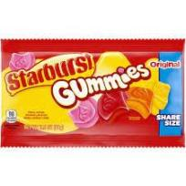 | STARBURST® Gummies Original Share Size 3.5oz | 10022000253092 | 136, 139, 140
10195414  10220867 | 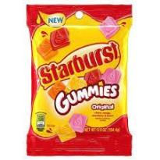 | STARBURST® Gummies Original Peg Pack 5.8oz | 10022000253818  00022000284648 | 136, 139, 140
10188301 | 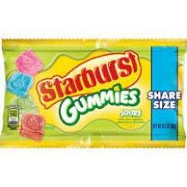 | STARBURST® Gummies Sours  Share Size 3.5oz | 10022000253122 | 134,135, 137-142
10195413  10220796  10195750 | 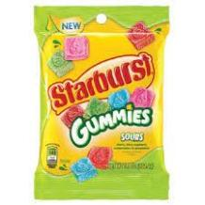 | STARBURST® Gummies Sours  Peg Pack 5.8oz | 10022000253801  00022000284617  10022000259384 | 134,135, 137-142
10220865 | 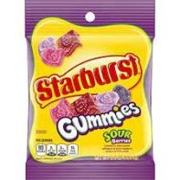 | STARBURST® Gummies Sour Berries  Peg Pack 5.8oz | 00022000284624 | 135, 138, 139
10222236  10136761  10222238 | 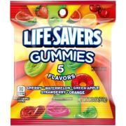 | LIFE SAVERS® Gummies Five Flavor Peg Pack 7.0oz, 3.22oz | 10022000285277  10019000083422  10022000285291 | 136, 139
10081699  10195012 | 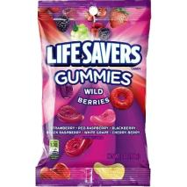 | LIFE SAVERS® Wild Berries Gummies Peg Pack 7.0 oz | 10019000083446  10022000244502 | 136 – 138, 140, 147, 149 - 152
10195000  10195014  10095001 | 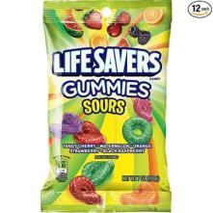 | LIFE SAVERS® Sour Gummies Peg Pack 7.0 oz, 180g | 10022000242058  10022000244533  00019000170491 | 132-134, 139-140, 144-147, 149, 151, 152, 201
10224068  10228324  10229828 | 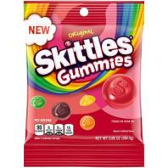 | SKITTLES® Gummies Original Peg Pack 5.8 oz, 2.93oz | 10022000285956  00022000286727  10022000287363 | 139 - 218
10229823  10230187 | 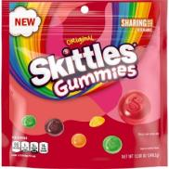 | SKITTLES® Gummies Original Stand Up Pouch 12oz | 10022000287325  00022000287434 | 139 - 218
10224070  10228325  10229830 | 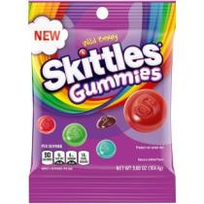 | SKITTLES® Wild Berry Gummies Peg Pack 5.8 oz, 2.93oz | 10022000285970  00022000286734  10022000287387 | 138 - 218
10229825  10230290 | 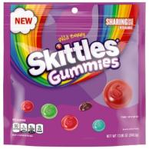 | SKITTLES® Gummies Wild Berry Stand Up Pouch 12oz | 10022000287349  00022000287441 | 138 - 218
10240169  10242246  10240168 | 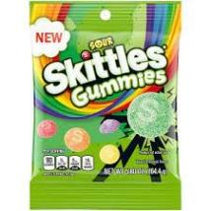 | SKITTLES® Sour Gummies Peg Pack 5.8 oz | 10022000289749  00022000291073  00022000289735 | 204 - 218

Please immediately examine your inventory and quarantine product subject to recall. In addition, if you may have further distributed this product, please identify your customers and notify them of this product recall. This recall should be carried out to the consumer level.
This recall is being made with the knowledge of the Food and Drug Administration.
For product currently in customer distribution centers your Customer Care Representative will contact you to identify case quantities and initiate the pick-up / return of the impacted items. Should the customer process be to destroy on-hand inventory of impacted items the enclosed FDA Recall Response Form is required identifying case quantities and batch codes.

For product currently in-store or on-shelf we have contracted RQA to assist with product removal for direct buying customers and they will begin visiting impacted retail locations immediately. Should customer process be to destroy on-hand inventory of impacted items and not have RQA handle product removal, the FDA Recall Response Form is required identifying case quantities and batch codes. If any affected product is found prior to RQA visiting, the product should be removed from store shelf, destroyed and documented on the FDA Recall Response Form. Indirect customers are requested to contact RQA directly to secure product retrieval service.

Please note that thorough completion of the FDA Recall Response Form is necessary for reimbursement and reshipment of new product. The FDA Recall Response Form should be sent to CustomerProductFeedback@effem.com as soon as possible.

Our continued partnership is extremely important to us. We apologize for any inconvenience caused to your customers and associates because of this voluntary withdrawal. We remain committed to delivering outstanding products and service to you and your organization. Your Mars Wrigley representative is available at any time to answer any questions you may have.

Thank you for your ongoing partnership and support.

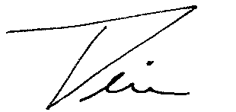
Timothy LeBel
President US Sales
Mars Wrigley

